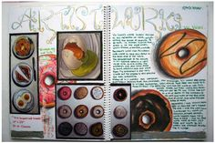 | Studio in Ceramics  Mr. Martin

Ceramics Exploration and Independent Research
Throughout the semester you will conduct your own investigation of different types of clay art and artists. This work can be conducted in class (during down moments) or at home.
Choose four topics of investigation; two ancient and two modern. You may pick from the provided lists or choose your own. Find out as much as you can about each topic. Two will be due at the end of first quarter and two at the end of second quarter. The research will be kept in your sketchbook and should include:
- Notes and sketches of the artwork filling at least two pages (across the gutter) in your book.
- Visuals. These can be drawn or printed and attached (or both).
- Include basic information such as:
  - A description of what the artist or type of work is all about.
  - Important dates
  - Origin/location: where the artist or group is from and how that place influenced the work. (color choices, style, materials)
  - Important artists or influences.
  - What are the defining characteristics of the artwork?
  - Your personal opinion/impression
  - Technical aspects of the construction of the work
  - Important historical events of the period.
  - How is the work reflective of the thoughts and lives of the people who lived when the work was made?
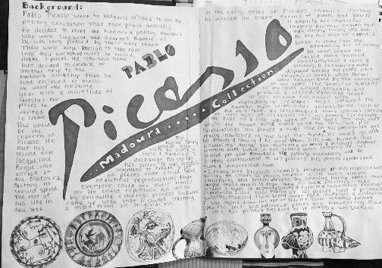 | 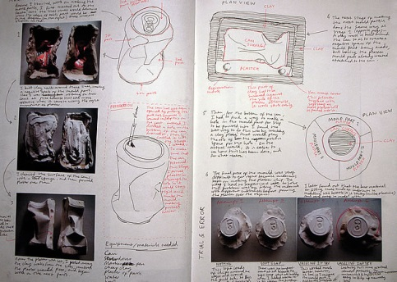 | 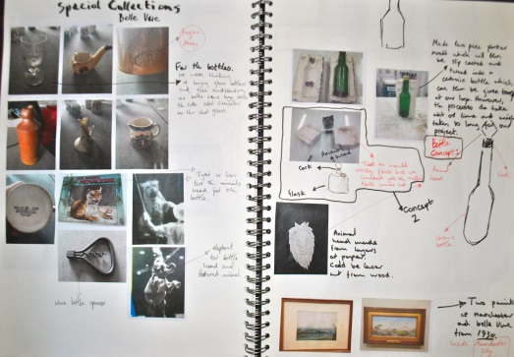
Types of Artwork/Topics of Interest:
Paleolithic cave claywork
Windsor Tradition of Southern New England
Jomon ware and culture
Sumeria + Asia Minor ware and figures
Egyptian Tomb and ceremonial objects
Minoan and Mycenaean cultures and ware
Chinese culture thru Qin Dynasty
Pre-Columbian ritual vessels and figures
Colima dogs and figures
Archaic, Hellenic, and Hellenistic ceramics
Etruscan funerary wares
Haniwa figures
Han, Tang, and Song Dynasty wares
Medieval tableware
Maiolica and Majolica
Persian, Indian, and Islamic patterning and decoration
Export wares of China and Southeast Asia: 16/17cce
Hispano-Moresque ceramics
African Tribal sculpture and functional patterning
Mimbres, Anasazi and Native American Traditions
Ming and Qing Dynasty wares
Tile Murals and wall installations
Art Deco and Art Nouveau

Clay Artists:  Ray Meeker  Nadir Khalili  Jun Kaneko  Peter Voulkos  Paul Soldner  Rudy Autio  Pablo Picasso  Joan Miro  Beate Kuhn  John Glick  Shiho Kanzaki  Peter Voulkos  Annie Woodford  Hara Kiyoshi  Abe Anjin  Carol Long  Ellen Schon  Victor Spinski | 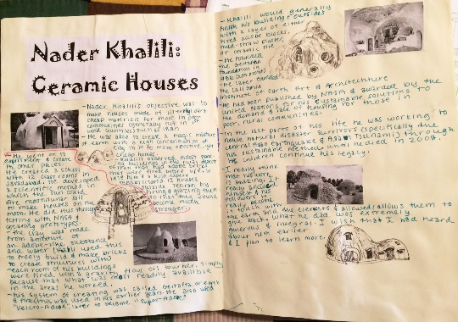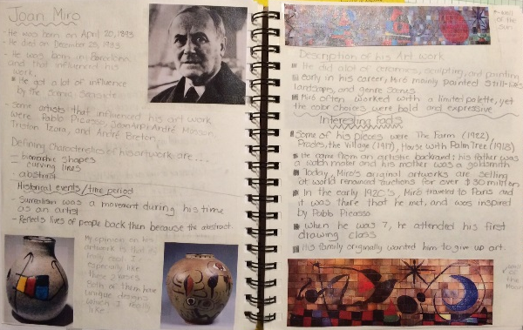  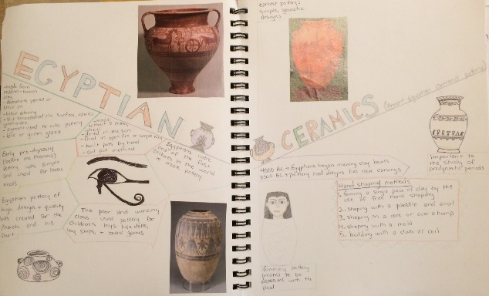

Note: If you choose an individual artist and the information you find is not enough to fill two pages, find another artist who works in a similar style and talk about how they are related.

